Module/SCO |  | Lesson/Section |  |  | Screen Number
Module 1: EMTALA Basic Training Orientation |  | Lesson 1: Training Navigation Highlights |  |  | EMTALA Basic_M1L1_Screen_10
Page Title | N/A |  | Narration | Module 1: EMTALA Basic Training Orientation  Lesson 1: Training Navigation Highlights
Text | N/A |  | Narration
Graphic | Insert: EMTALA Basic_M1L1_Screen_10.mp4  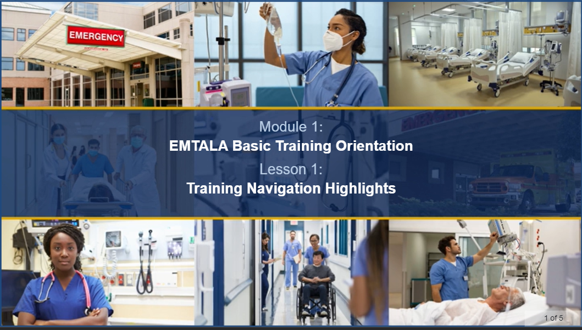 |  | Narration
Alt-Tag Text | Collage of photos representing medical personnel and emergency departments. |  | Notes | Animated title screen will appear supported by collage of hospital-related images. No bulleted screen text will appear.

Module/SCO |  | Lesson/Section |  |  | Screen Number
Module 1: EMTALA Basic Training Orientation |  | Lesson 1: Training Navigation Highlights |  |  | EMTALA Basic_M1L1_Screen_20
Page Title | Training Navigation Highlights: Overview |  | Narration | Hello! My name is Jennifer, and I’ll be your guide throughout the Emergency Medical Treatment and Labor Act, known as EMTALA, Basic Training. Let’s review the navigation highlights, which are accessible from any screen in this training.
Text | N/A |  | Narration
Graphic | Insert: EMTALA Basic_M1L1_Screen_20.mp4  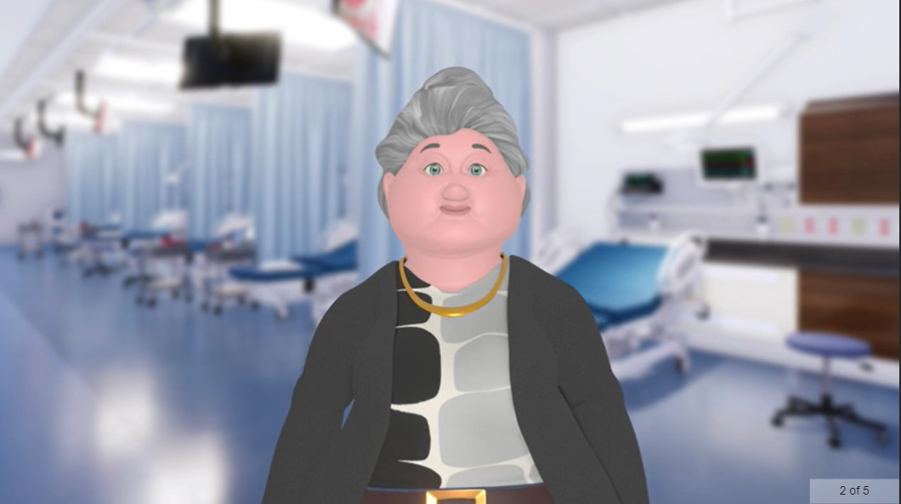 |  | Narration
Alt-Tag Text | Animated character, Jennifer, introducing lesson content. |  | Notes

Module/SCO |  | Lesson/Section |  |  | Screen Number
Module 1: EMTALA Basic Training Orientation |  | Lesson 1: Training Navigation Highlights |  |  | EMTALA Basic_M1L1_Screen_30
Page Title | Training Navigation Highlights: Objectives |  | Narration | After completing this lesson, you will be able to identify standard navigation controls available for the training and identify how to access training resources, acronyms, help, and the training roadmap.
Text | - Identify standard navigation controls available for the training.  - Identify how to access training resources, acronyms, help, and the training roadmap. |  | Narration
Graphic | Insert: EMTALA Basic_M1L1_Screen_30.mp4  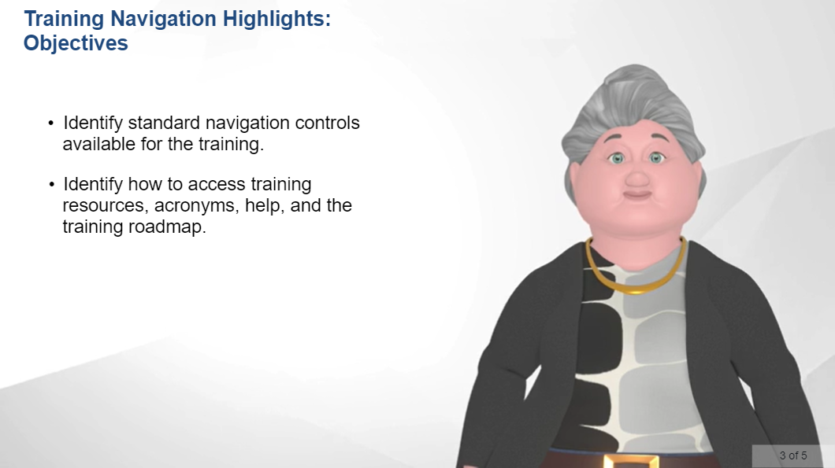 |  | Narration
Alt-Tag Text | Animated character, Jennifer, introducing lesson objectives. |  | Notes | Animated character will be used for all Objectives and Summary screens.

Module/SCO |  | Lesson/Section |  |  | Screen Number
Module 1: EMTALA Basic Training Orientation |  | Lesson 1: Training Navigation Highlights |  |  | EMTALA Basic_M1L1_Screen_40
Page Title | Training Navigation Controls |  | Narration | Before we get started, let’s review how to navigate confidently through the training—we’ll start with a brief tour of the navigation controls. On the left side of the screen, you’ll find the Menu tab, which identifies each screen title in the lesson. Under the Transcript tab, you can access a text version of the audio for each screen. The Resources tab provides links to important information, such as the acronym list and reference material, related to the EMTALA Basic Training. You can hide or show these tabs by selecting the three-line icon at the left of the training title.  At the bottom of the screen, you will find the primary navigation controls. Select the Gear button to open the accessibility controls menu, which includes options for “Zoom to fit,” “Accessible text,” and “Keyboard shortcuts.” Toggling “Zoom to fit” on enables you to use scroll bars on the right side of and below the graphic content to enlarge it by up to 200 percent. Toggling “Accessible text” on provides tools you can use to increase font size and line spacing and make other formatting changes to enhance the way you view text. Toggling “Keyboard shortcuts” on enables you to press Shift and ? at any time to see a list of keyboard shortcuts. Select the Closed Caption button to turn the captions—which transcribe the audio accompanying the screen—on or off. You can adjust the audio level by using the Volume Control button. The progress bar includes controls to Pause, Resume, or Restart the lesson’s audio. Use the Previous and Next buttons to navigate between screens in the lesson.  At the top right of your screen are the Roadmap and Help buttons. The Roadmap button identifies your location within the training’s module and lesson structure. The Help button allows you to access this tutorial any time you need a refresher. On devices with smaller screens, such as mobile phones and tablets, you may see an ellipsis symbol instead of the two buttons; select the ellipsis symbol to access the buttons.
Text | N/A |  | Narration
Graphic | Insert: EMTALA Basic_M1L1_Screen_40.mp4  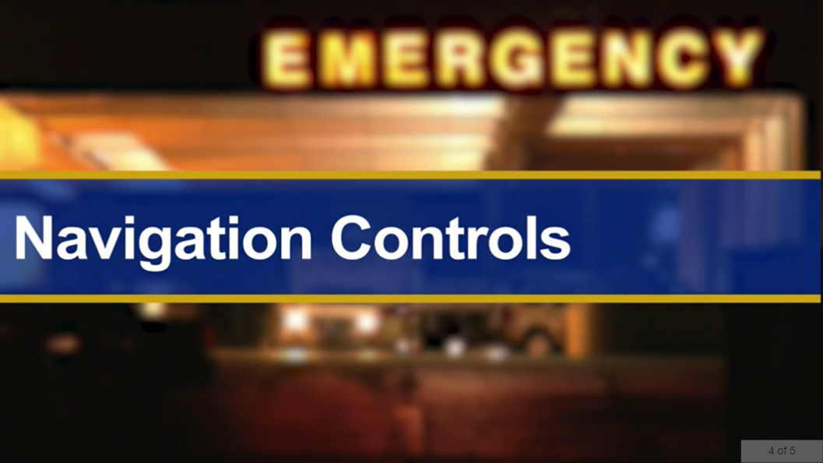 |  | Narration
Alt-Tag Text | Video demonstrating lesson’s navigation controls. |  | Notes

Module/SCO |  | Lesson/Section |  |  | Screen Number
Module 1: EMTALA Basic Training Orientation |  | Lesson 1: Training Navigation Highlights |  |  | EMTALA Basic_M1L1_Screen_50
Page Title | Training Navigation Highlights: Summary |  | Narration | In this lesson, you learned to identify the standard navigation controls available for the training and how to access training resources, acronyms, help, and the training roadmap.  Select Exit at the top-right corner of the screen to return to the training menu.
Text | - Identify standard navigation controls available for the training.  - Identify how to access training resources, acronyms, help, and the training roadmap. |  | Narration
Graphic | Insert: EMTALA Basic_M1L1_Screen_50.mp4  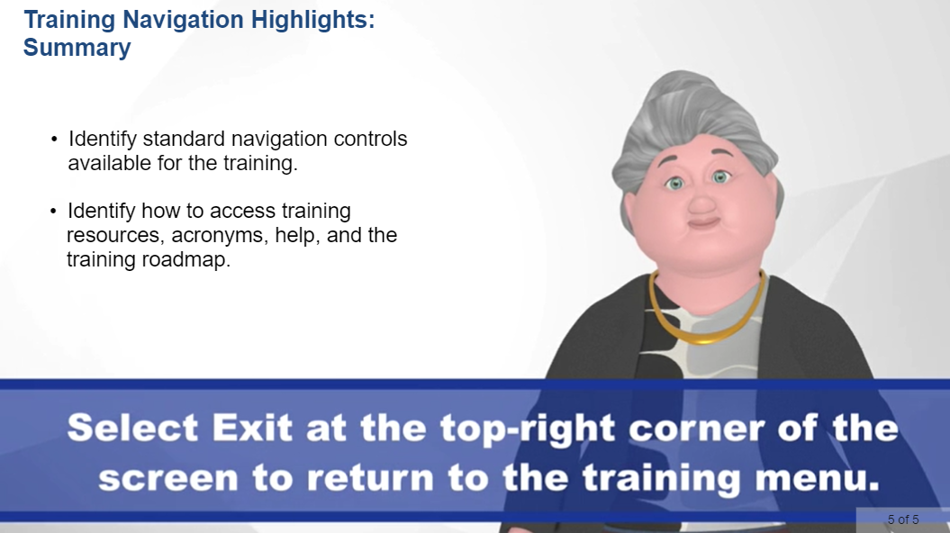 |  | Narration
Alt-Tag Text | Animated character, Jennifer, providing lesson summary. |  | Notes | Animated character will be used for all Objectives and Summary screens.

